Project Design Phase - II Data Flow Diagram & User Stories
Date Team ID
Project Name Maximum Marks
25 October 2022 PNT2022TMID
44492
Signs With Smart Connectivity For Better Road Safety 4 Marks

Data Flow Diagrams:
A Data Flow Diagram (DFD) is a traditional visual representation of the information flows within a system. A neat and clear DFD can depict the right amount of the system requirement graphically. It shows how data enters and leaves the system, what changes theinformation, and where data is
stored.
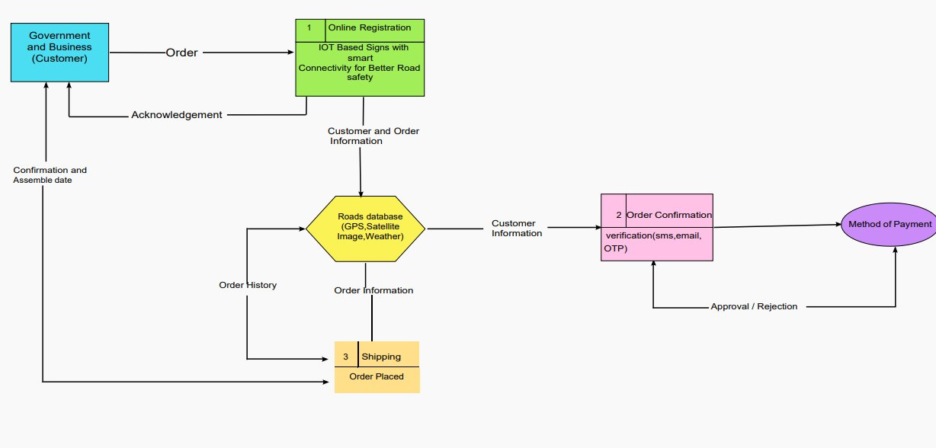
Data Flow Diagram- Signs with smart connectivity for better road safety:
User Stories

Use the below template to list all the user stories for the product.
User Type | Functional Requirement (Epic) | User Story Number | User Story / Task | Acceptance criteria | Priority | Release
Customer (Mobile user) | Registration | USN-1 | As a user, I can register for the application by entering my email, password, and confirming my password. | Access my account / dashboard | High | Sprint-1
Weather | openweathermap | USN-2 | As a user, I want to check the weather of that location | Get the weather of that location | High | Sprint-1
IoT devices | Automation | USN-3 | As a user, I want to use IoT devices for automation purposes | Get the work done without manual effort | High | Sprint-2
Python code | Random data | USN-4 | As a user, I want to give some input to the devices for performing some action to complete the tasks very easily | Get the data workflow | Medium | Sprint-1
IBM Cloud | Cloud services | USN-5 | As a user, I want to deploy these application for public version | Useful for all domain users | High | Sprint-1
Node-Red | Integration | USN-6 | As a user, I want to integrate the applications with hardware | To precise for linear workflow | Medium | Sprint-3
Web UI | Interaction | USN-7 | As a user, I want to interact with the digital products | To interact with the users | Medium | Sprint-2
Data validation | Checking accuracy | USN-8 | As a user, I can check the ability and accuracy of the model in obtaining the required information | Check the capability of the model | High | Sprint-2
Data extraction | Obtaining the data | USN-9 | As a user, I can retrieve the result data from the application for data storage for further uses | Download the result in the form of data | High | Sprint-3

